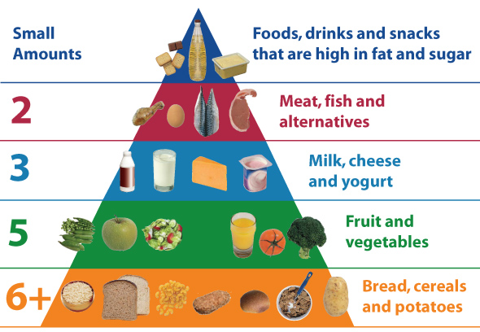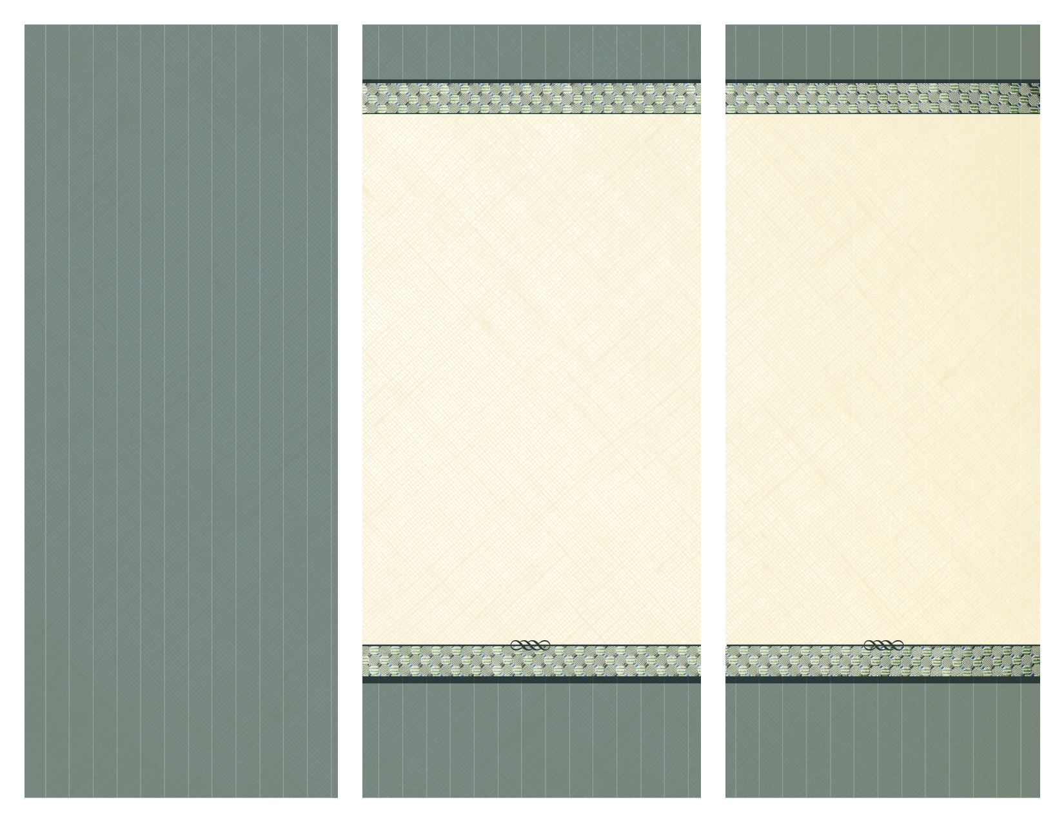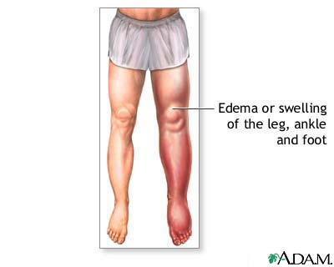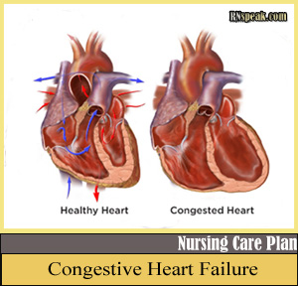

A good tool to use when searching for food to intake

Patients with CHF should:

* Choose plenty of fruits and vegetables
* Eat foods such as fresh meats, poultry, fish, dry and fresh legumes, eggs, milk, yogurt, plain rice, pasta and oatmeal
* Season with herbs, spices, herbed vinegar and fruit juices
* Check nutrition facts on labels for sodium content
* Stay away from processed food
* Use less condiments

REDUCE SODIUM

Dietary

Considerations

Erin Farley

Pre-Medicine

Block 3

Congestive

Heart

Failure

(CHF)

* www.webmd.com
* www.mayoclinic.org
* http://www.ucsfhealth.org

.

Works Cited

* Medication to lower blood pressure and improve blood flow
* More blood pressure pills without the side effect of persistent coughing
* Medication to slow heart rate and increase the strength of the heart contractions
* Diuretics: Prevent fluid from building up anywhere in the body
* A synthetic version of B-type natriuretic peptide (BNP), a hormone that occurs naturally in your body
* Medication to reverse scarring of the heart

**Medications**

Swollen leg, ankle, and heart

*diagnostic tool

**Congestive Heart Failure** makes blood move slower through the heart and body, causing increased pressure on the heart. Different chambers of the heart are forced to compensate which results in weakened muscle walls.

The kidneys respond by triggering the body to retain fluid and salt.

* **Shortness of breath** when you exert yourself or when lying down
* **Swelling** in the legs, ankles, and feet (dt*)
* **Elevated** blood pressure (dt)
* **Rapid or irregular** heartbeat (dt)
* **Decreased** alertness
* **Persistent** coughing or wheezing with **white or blood-tinged** phlegm (dt)
* **Lack** of appetite

Symptoms

A healthy heart versus a congested heart

Pathophysiology